Database Technical Documentation

Entity Relationship Model
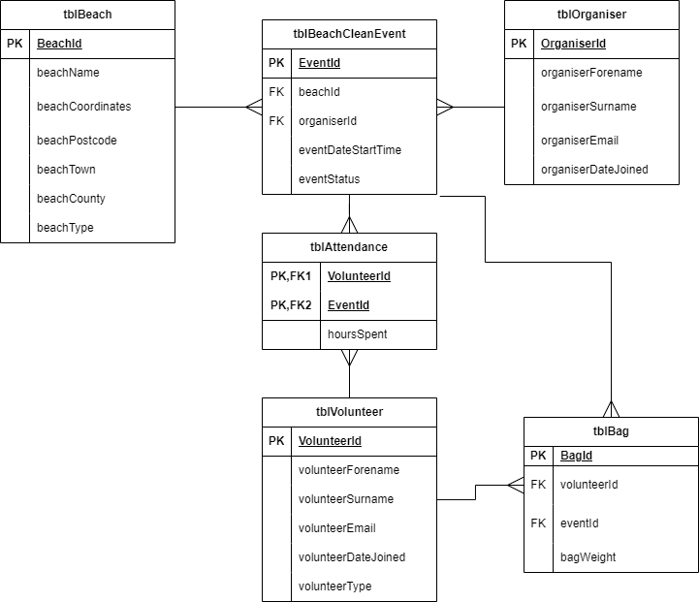

Data Dictionaries
tblBeach – Beach Table
Field Name | R | I | Data Type | Len | Validation Rule | Default Value | Description | Typical Data
beachId | Y | Y | INT | N/A | Unique, numeric, auto-increment | N/A | Primary key; unique identifier for each beach | 1,2,3
beachName | Y | N | VARCHAR | 100 | Unique, non-empty string, max 100 characters | None | The name of the beach | “Ballyholme Beach”
beachCoordinates | Y | N | VARCHAR | 50 | Max 50 characters | None | Coordinates of the beach | “54.6537, -5.6694”
beachTown | Y | N | VARCHAR | 50 | Max 50 characters | None | Town the beach is in | “Bangor”
beachCounty | Y | N | VARCHAR | 50 | Max 50 characters | None | County the beach is in | “Down”
beachPostcode | Y | N | VARCHAR | 10 | Max 10 characters | None | Postcode of the beach location | “BT20 5NE”
beachType | Y | N | ENUM | N/A | Must be “Sand,” “Shingle” or “Unknown” | “Unknown” | The type/surface of the beach | “Sand,” “Shingle”, “Unknown”
Stores information on each beach location managed by the organisation.

tblBag – Bag Table
Field Name | R | I | Data Type | Len | Validation Rule | Default Value | Description | Typical Data
bagId | Y | Y | INT | N/A | Unique, numeric, auto-increment | N/A | Primary key; unique identifier for each bag | 1,2,3
bagWeight | Y | N | DECIMAL (6,3) | N/A | Must be a positive number, max 3 decimal places | None | Weight of rubbish collected in the bag (kg) | 5.250
volunteerId | Y | N | INT | N/A | Must match an existing volunteerId in tblVolnteer | None | Foreign key: referencing the volunteer who collected the bag | 1,2,3
eventId | Y | N | INT | N/A | Must match an existing eventrId in tblEvent | None | Foreign key: referencing the event at which the bag was collected | 1,2,3
Stores information about each bag of rubbish collected at each beach clean event.

tblEvent – Event Table
Stores Information on events.
Field Name | R | I | Data Type | Len | Validation Rule | Default Value | Description | Typical Data
eventId | Y | Y | INT | N/A | UNIQUE, AUTO_INCREMENT, NUMERIC | N/A | Primary key: unique identifier for every event | 2,4,6
eventDateStartTime | Y | N | DATETIME | N/A | DATETIME, NOT NULL | N/A | The time the event began | “2026-03-20 10:00:00”
eventStatus | Y | N | ENUM | N/A | Must be either “completed” or “uncompleted” | “Uncompleted” | Whether or not the event has taken place | “completed”
beachId | Y | Y | INT | N/A | Must match an existing beachID in tblBeach | N/A | Foreign key: referencing the beach the event took place on | 2,4,6
organiserId | Y | Y | INT | N/A | Must match an existing organiserID in tblOrganiser | N/A | Foreign key: referencing the organiser of the event | 2,4,6

tblAttendance – Attendance Table
Stores Information on events.
Field Name | R | I | Data Type | Len | Validation Rule | Default Value | Description | Typical Data
volunteerId | Y | Y | INT | N/A | Must match an existing volunteerIDin tblVolunteer | N/A | Foreign Key: referencing what volunteer attended an event | 2,4,6
eventId | Y | Y | INT | N/A | Must match an existing eventID in tblEvent | N/A | Foreign Key: referencing the event a volunteer attended | 2,4,6
hoursSpent | Y | N | INT | N/A | NOT NULL | 0 | Hours a volunteer spent at an event | 2,4,6

Field Name | R | I | Data Type | Len | Validation Rule | Default Value | Description | Typical Data
organiserId | Y | Y | INT | N/A | Unique, numeric, auto-increment | N/A | Primary key; unique identifier for each beach | 1,2,3
organiserForename | Y | N | VARCHAR | 255 | Max 100 characters, Not NULL | None | Forename of the volunteer | “Ryan”, “Marcel”
organiserSurname | Y | N | VARCHAR | 255 | Max 255 characters, Not NULL | None | Surname of the volunteer | “Meijer”, “Logue”
organiserEmail | Y | N | VARCHAR | 255 | Must be email, Max 255 characters, Not NULL | None | Email address of the volunteer | “rmeijer01@qub.ac.uk”
organiserDateJoined | Y | N | DATE | N/A | Must be date, Not NULL | None | Date the volunteer joined | “10/01/2024”
tblOrganiser – Organiser Table
Stores Information on organisers.

Field Name | R | I | Data Type | Len | Validation Rule | Default Value | Description | Typical Data
volunteerId | Y | Y | INT | N/A | Unique, numeric, auto-increment | N/A | Primary key; unique identifier for each beach | 1,2,3
volunteerForename | Y | N | VARCHAR | 255 | Max 100 characters, Not NULL | None | Forename of the volunteer | “Ryan”, “Marcel”
volunteerSurname | Y | N | VARCHAR | 255 | Max 255 characters, Not NULL | None | Surname of the volunteer | “Meijer”, “Logue”
VolunteerEmail | Y | N | VARCHAR | 255 | Must be email , Max 255 characters | None | Email address of the volunteer | “rmeijer01@qub.ac.uk”
volunteerDateJoined | Y | N | DATE | N/A | Must be date | None | Date the volunteer joined | “10/01/2024”
volunteerType | Y | N | ENUM | N/A | Must be “Active,” “Inactive” | “Active” | Whether a volunteer still participates | “Active”,” Inactive”
tblVolunteer – Volunteer Table
Stores Information on volunteers.
CRUD Requirements
Beach Table
- Create – Add a new beach record.
- Read – View all current beach records in a table format.
- Update – Edit any existing beach records.
- Delete – Remove an existing beach record.
Bag Table
- Create – Add a new bag record.
- Read – View all current bag records in a table format.
- Update – Edit any existing bag records.
- Delete – Remove an existing bag record.
Beach Clean Event Table
- Create – Add a new event record.
- Read – View all current event records in a table format.
- Update – Edit any existing event records.
- Delete – Remove an existing event record.
Volunteer Table
- Create – Add a new volunteer record.
- Read – View all current volunteer records in a table format.
- Update – Edit any existing volunteer records.
- Delete – Remove an existing volunteer record.
Organiser Table
- Create – Add a new organiser record.
- Read – View all current organiser records in a table format.
- Update – Edit any existing organiser records.
- Delete – Remove an existing organiser record.
Attendance Table
- Create – Add a new attendance record.
- Read – View all current attendance records in a table format.
- Update – Edit any existing attendance records.
- Delete – Remove an existing attendance record.

Business Questions for Reporting
- How many events has each volunteer attended?
- How long are volunteers spending at events?
- Who collects the most efficiently? (bag weight per hour spent)
- How much total rubbish is collected at each event?
- Who organises the events with the highest attendance?
- Which events have the most hours attended?
- How much rubbish is collected at each beach?
- How many events are organised for each beach?
- Which beaches have been cleaned most recently?

